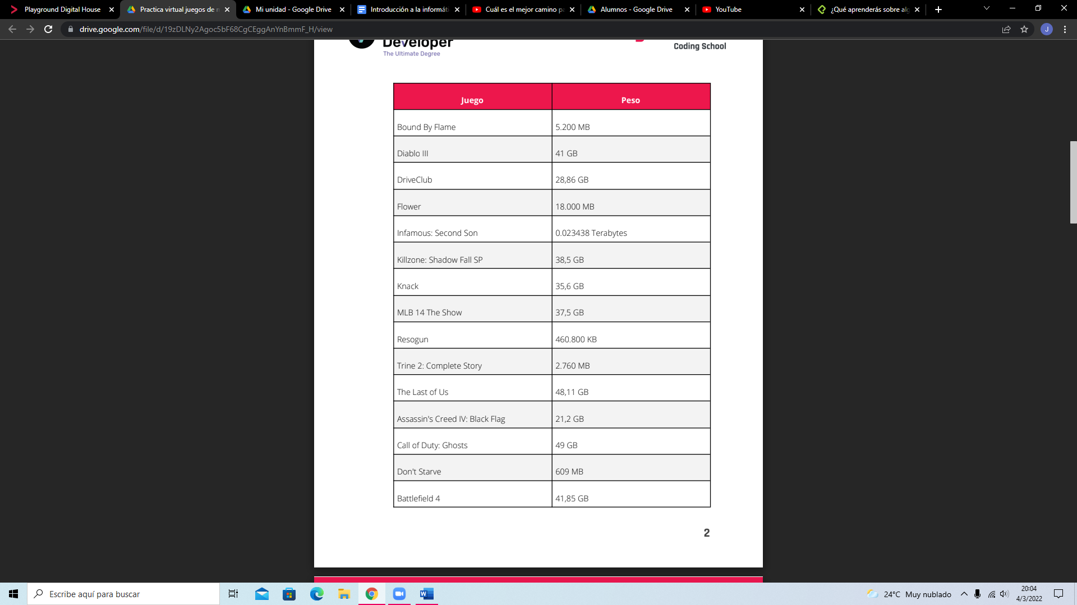

Bound by flame 5.0781 gb

Dont’t Starve 0.59

Trine 2: Complete story 2.7 gb

Resogun 0.576 gb

Flower 18 gb

Infamous: Second son 24gb

Assassin’s creed 21,2gb

DriveClub 28,86 gb

Knack 35,6 gb

MLB 37,5 gb

Killzone 38,5 gb

Diablo III 41 gb